Quiz 2 ***(CSE331L.7 – Asif Ahmed Neloy_Summer’20)***

Department of Electrical and Computer Engineering

School of Engineering and Physical Sciences

North South University, Bashundhara, Dhaka-1229, Bangladesh

*Time 20 minutes, Marks 20 (You need to answer all questions).*

***Name – SADMAN ALAM***

***ID – 1610544042 0/10***

1. **Write a program in Assembly language that will adds the even index values from an Array of Size 20.**

**Where is the code?**

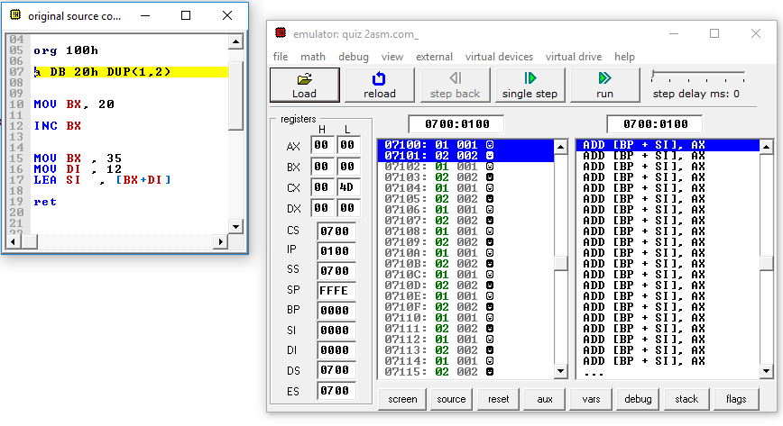

**End**